|  |  |
| --- | --- |
| **Canon RF 50mm f/1.2L USM Lens**  Ống Kính Canon RF 50mm f/1.2L USM  Canon RF 50mm f1.2L USM 1 Canon RF 50mm f1.2L USM 4 Canon RF 50mm f1.2L USM 3 Canon RF 50mm f1.2L USM 2 | **Featured information:**   * Ring-shaped ultrasonic focusing motor * Aperture: f/1.2 - f/16 * One UD lens, One aspherical lens * RF/Full-Frame Lens   Price : 1400$  **Specifications:**   * **Focal distance:** 50mm * **Largest Aperture:** f/1.2 * **Smallest Aperture:** f/16 * **Lens Mount:** Canon RF * **Lens Format:** Full-Frame * **View:** 46° * **Minimum Focus Distance:** 40cm * **Magnification:** 0.19x * **Optical Components:** 15 Elements in 9 Groups * **Number of Mouth Blades:** 10 * **Focus Type:** Auto focus * **Anti-Vibration:** No * **Filter Size:** 77 mm (Front) * **Size:** 89.8 x 108 mm * **Weight:** 950 g |

**Description:**

**Ability to capture eye-catching Bokeh effects**

Designed with 10 rounded aperture blades, the Canon RF 50mm helps photographers possess the most sparkling and quality bokeh images.



**50mm fixed focal length lens, F/1.2 aperture**

The Canon RF 50mm f/1.2L USM is a 50mm fixed focal length lens with full-frame optical performance that delivers images with greater sharpness and detail. The aperture can be opened to F/1.2 to help highlight the subject, giving the best image quality, suitable for filmmakers or photographers shooting with a thin depth of field.

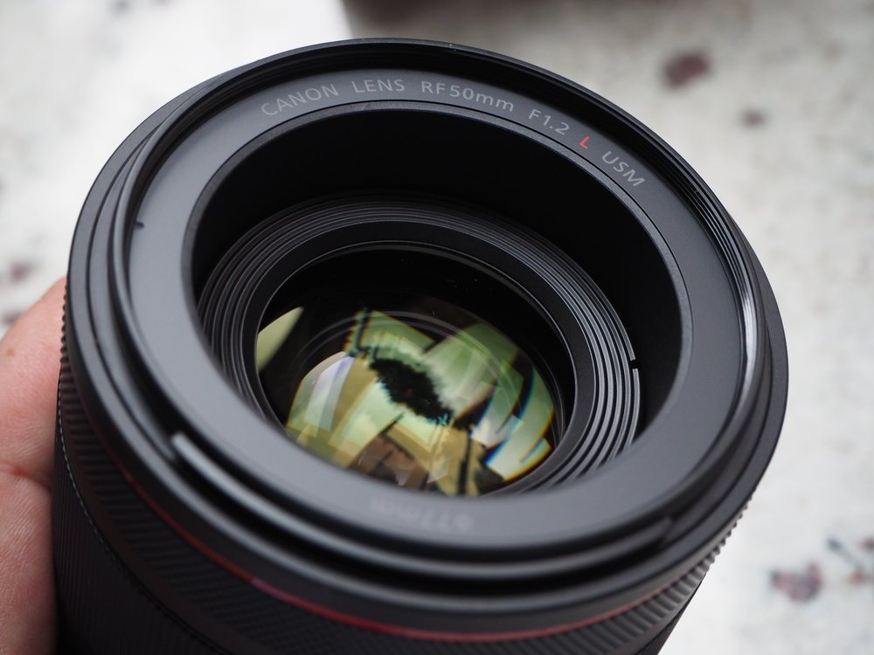

With a focal length of 50mm and flexible aperture up to F/1.2, users can take a variety of photos with many different styles even in difficult lighting conditions such as street photography...